COST SHEET OF EVENT
NewRosedaleHouse.com - (313)444-9425
18845 West McNichols • Detroit, MI 48219
Event Date______________________ Type_________________________
Time of Event:__________to____________ Additional Hrs. $100/hr. (5hrs/3hrs)
KITCHEN RENTAL $__________________$250 (Cooking/Use of Stove in Kitchen Additional Set Up Hour)
$100 (Storage, Washing, Freezer, NO STOVE USAGE etc.) -
HALL $__________________Sat - $895 Fri - $795 (5hrs) M-Th. - $595 Sun - $550 Shower/Repast/Event Prior to 6pm (3hrs.)

Holiday dates will be slightly higher
FOOD $________________________________ (Starting at $15/ Plate Ask About Our Menu)
SECURITY $_____________________________$295 (3 armed and licensed)
ALL NEW CLEAR VIEW 360 SPIN $279/HR – 2HR MIN.
Additional Hours/Per Usage available after the minimums are met.
We are restricting outside 360 booths in the facility. It is limited to our exclusive Clear View 360.
LINEN $________________________________$16/Table NAPKINS $________________________ .40/Napkin
CHAIR COVERS $__________________________$2.95 (SASH COLOR :_______________________)
DAMAGE DEPOSIT $______________________$200
(Refundable in 3 – 5 business days in check form. YOUR DEPOSIT WILL NOT BE REFUNDED IF SMOKING or IF TRASH IS NOT REMOVED.)
VALET $___________________________$450 (Free to Guest)
Additional Rooms for Rental $__________________$75
SERVERS $__________________________$100/Person
ADDITIONALS (Total) $__________________
TOTAL$______________________________
Deposit $_____________________________
Balance Owed $_______________________
Pd By:___________________________________________________ Date_________________________

FACILITY SET-UP (Check boxes for tables that apply to set-up.)
IF SET-UP SHEET IS NOT PROVIDED a week PRIOR to EVENT… You will be required to arrange Tables and Chairs or pay a $25 SET-UP FEE.
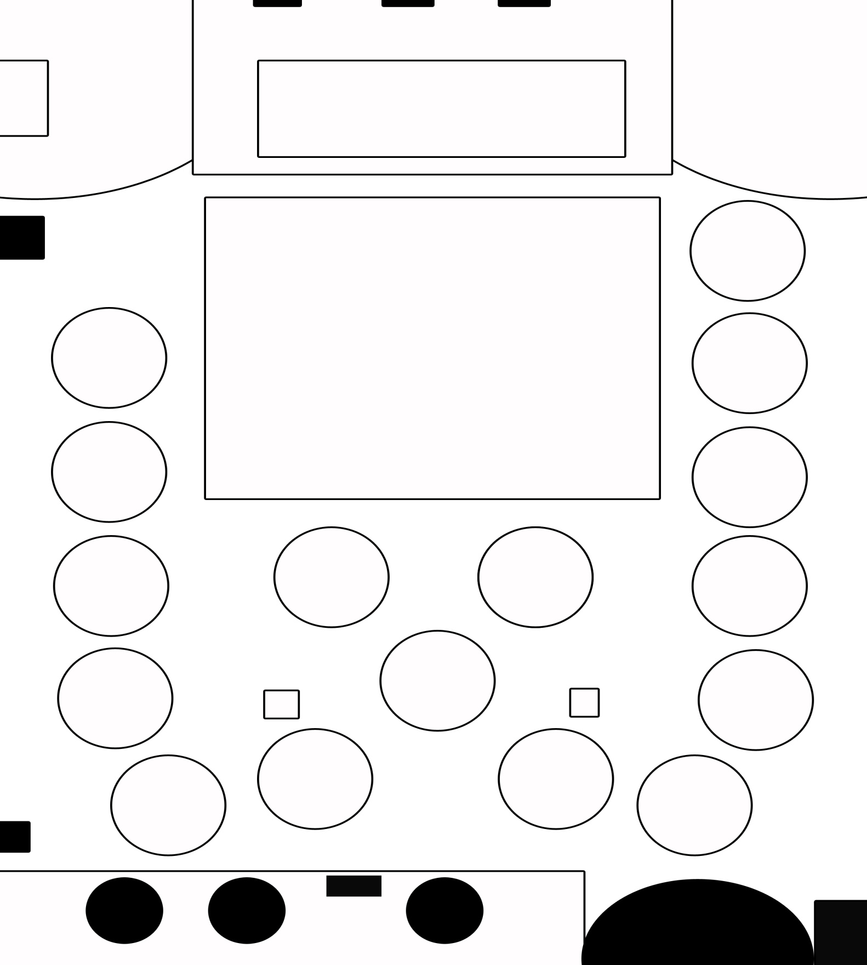

DANCE FLOOR

REAR
Official Contract
Agreement made this ______________ day of ________________________________ ________, between The NEW
NEW ROSEDALE HOUSE located at 18845 W. McNichols, Detroit, Michigan and the following:
(COPY OF ID REQUIRED): Screenshot and forward to: Rosedalebanquets@gmail.com
Name_________________________________________Address___________________________________________
City State Zip___________________________________Email_____________________________________________
Phone Number______________________________________________Cell Number__________________________
Time: ___________________ til __________________Date:____________________________
Cash App Name: ________________________________________________________
Up to 5 Hours. There is an allotted 2 hours prior to event start time for décor. Additional time is at $75/Hr.
It is agreed that The New Rosedale House will provide the following:

I, ________________________________________________________________(NAME) have agreed to pay The
New Rosedale House the sum of $ _______________________________dollars for the following:
- Hall Rental $_________________________

- Food for __________guests. Number of expected guest (Set-up purposes only.)__________.

DINNER STYLE: _________________________________
MENU# 1 2 3 4 Custom

- Optional Services (See detailed sheet for explanation):
Security (MANDATORY) - $295

If not at least two (2) licensed and professional security personnel are provided the date of function. Security will be provided and charged. Name of security company/personnel and Contact Information:

Serving out Of Kitchen (including Sink Usage) - $100
Kitchen Rental (Storage Only) - $75
Cooking in Kitchen - $300
Damage Deposit - $200 (Refundable - MANDATORY)
Reservation Deposit - $150 (Secure your date)
- REFUND ON DEPOSITS: A non-refundable deposit of $150.00 is required to hold the night in question. NO REFUND ON DEPOSITS.
- Deposits will be deducted from the total bill, additional payments are to be made as follows:

PAYMENT SCHEDULE: PAYMENTS MUST BE FINALIZED 7 – 10 DAYS prior to the event to avoid a $50 additional charge.
60 Days Prior Date__________________By:__________Payment Pd. Date_______________$
30 Days Prior Date__________________By:__________Payment Pd. Date_______________$
10 Days Prior Date__________________By:__________Payment Pd. Date_______________$
A NON NEGOTIABLE for the DAMAGE DEPOSIT RETURN:
- There should be nothing damaged, cut, destroyed, dented, busted, stained, soiled, removed, missing, chipped or scratched. This includes but is not limited to the following: Missing furniture, tables, chairs, table cloths, curtains, podiums, plants, decorations (provided by NRH), utensils, appliances, any objects permanently or non-permanently affixed, mirrors, dishes, speakers, audio equipment, etc.

- EXITING: Party and guests are expected to vacate the property within thirty minutes of the time stated on the contract. For example, if end time is 12 midnight no one should be on the premises after 12:30a.m. For each additional fifteen minutes there is a $30 CHARGE/ 15 minutes. ________
CLEANING: Guest who are utilizing the kitchen should also make sure the kitchen area is cleaned properly as well, including but not limited to mopping of the floor, making sure the drains, sinks and stoves are cleaned. Clients may be subject to forfeiting their damage deposit. Confetti, silly string, and glitter is not allowed; if used at the event there will be a $95 charge for additional clean-up. There is an optional prepaid cleaning fee available for $95. TAKING YOUR TRASH TO THE DUMPSTER IS MANDATORY! __________
DAMAGE DEPOSIT: After a complete inspection of the property, damage deposits will be refunded accordingly in the form of a check. Service fees, damage fees will be removed from the security deposit and the refunded amount will be based on the amount of damage, if any. The refund is made within 3 – 5 business days of the event. There are no exceptions. Signature acknowledging each term above: _________________________________________________
Total Due: ________________________+ 200 Damage Deposit = ________________________________

Rental Agent – Rosedale House Representative
______________________________________________________Date_____________________________________

Client Date

The New Rosedale House
Affidavit of Liability
AGREEMENT for services made this__________day of______________________in the year of our lord 20____, between Anthony Mitchell (owner)/ agent _______________________, hereinafter referred to as the establishment and ________________________ (client) , hereinafter referred to as the undersigned; WITNESSETH: that the Establishment is hereby retained to contract_______________________________
Services for the undersigned. The undersigned hereby hires the Establishment premises address known as _18845_W.McNichols in the country in WAYNE in the state of MICHIGAN to use and occupy for a strictly private affair.
We, the establishment ARE NOT RESPONSIBLE and shall HAVE NO LEGAL LIABILITY if Photos, Limo Service, Video Quality , food, linen, valet, coat check or any third party service or direct service contracted for the undersigned are not satisfactory. We are renting the facility in an as-is condition; including but not limited to the kitchen, hallways, bathrooms, hall, and/or additional rooms. There will be no additional alterations unless previously discussed and agreed upon. We are not responsible for stolen, lost, nor misplaced items, injuries, slip and falls, fatalities or any altercations deriving from guest disputes. In the event that any provision of the agreement is held or determined invalid or unenforceable for any reason, the Establishment, The New Rosedale House, shall remain unaffected by such holding or determination. All third party services are provided for the convenience of the undersigned, and we do not indent in any way to define or describe the scope or intent of any provision of their agreement.
This agreement embodies the entire agreement and the understanding between the undersigned and the Establishment supersedes all added its use, unless otherwise expressly stated. Available usage only to parents of the daycare.
Sign:_______________________________________

Date:_______________________________________

Rosedale Rep:_______________________________

Date:______________________________________

1. No group may use a room without scheduling said room (if available and can be accommodated) in person in
Advance of the date of use, signed a completed application form, and paid any deposits or fees required.
2. The New Rosedale House reserves the right to limit and/or deny requests for meetings or parties of minors. If a permit is issued for such a meeting/party, the application must be signed by the responsible party who is over 21 years of age. One chaperone must be provided for every 15 minors.
3. Trash pickup and other cleanup duties are to be performed by the rental group. Therefore, the room must be left in the condition in which it was found. Any decorations used must be disposed of properly, immediately following the function. No sparkle, glitter, confetti, etc. is permitted at The New Rosedale House. All candles must be protected with a glass enclosure. Tape, pins, staples or adhesive are not allowed on the walls, bars, etc. Security deposit will be forfeited if clean-up is not complete.__________
4. Routine maintenance will be done by The New Rosedale House staff, however, it is expected that the lessee will clear and clean any areas of The New Rosedale House used by the lessee or the lessee’s invitees. Furniture and equipment may not be moved from room to room or removed from the building without permission from the manager.
5. The Rental Representative is responsible for insuring that all rules and regulations are adhered to.
6. Buildings, grounds, and equipment shall not be used for activities which are in conflict with city policies and ordinances, state or federal laws, activities which are discriminatory in the legal sense, political activities, or illegal gambling.
7. All children in attendance must remain in the rented room(s). Children are not allowed to roam unsupervised in other areas of the building, such as hallways, rooms or lounges.
8. Room capacities MUST be adhered to. Rental groups may not overflow into the hallways and disturb other customers. Such behavior may result in immediate removal from the premises by New Rosedale House staff, the Detroit Police Department and/or a penalty fee.
10. Rental fees are based on the entire time a group/party is in the room, including set-up and clean-up.
11. Paper goods are the responsibility of the rental applicant and are not provided by The New Rosedale House.
12. The New Rosedale House will assume no liability for any property of the permit holder left in the building. The New Rosedale House will not be liable for any damages to lessee’s property or that of the lessee’s contractor if it is moved, cleaned or stored by our employees in the performance of their duties. The New Rosedale House will not assume liability for any personal property, merchandise or equipment left on the premise.
13. Any damages to the building and/or grounds will be charged to the Rental Representative signing the permit. The Rental Representative is responsible for checking the room for damages and cleanup in the company of The New Rosedale House personnel, before signing the Rental Verification Slip at the conclusion of the rental.
Initial ________

Initial ________

Initial ________

Initial _________

14. The New Rosedale House does not provide individual accident and health insurance. Groups using the facilities may be required to supply a certificate of insurance covering The New Rosedale House and the City of Detroit in case of accident or injury to participants. Minimum acceptable limits will be $3 million each occurrence and $3 million aggregate. The New Rosedale House must receive policy verification including dates of coverage and financial limits for this event at least 30 days before the first rental date.
15. The New Rosedale House reserves the right to act in the best interest of the rentals on items not specifically covered in these rules.
16. Equipment for use to rental groups must be utilized for its intended purpose.
17. The New Rosedale House is a smoke-free facility; guests may smoke in designated outside areas where ash containers are provided.___________
18. The New Rosedale House does not allow the placement of signs around the facility promoting events held at The New Rosedale House. Special permission may be granted by the Facility Manager. Failure to comply with this sign rule may result in forfeiture of some, or all, of the security deposit. The New Rosedale House reserves the right to request and require a copy of promotional materials (including social networks) and/or invitations that lessee creates for event/meeting.
19. The New Rosedale House reserves the right to inspect and control all events, private parties, meetings and receptions held on its premise. The lessee is responsible for all of The New Rosedale House property missing or damaged by guests, independent contractors, lessee, lessee’s agent or any person on lessee’s behalf. The lessee is responsible for all fees should additional City staff be required to control event. _________
20. The lessee agrees that it will not sell or give away food or beverages or permit same to be consumed on the premises unless authorized to do so by the Manager.
21. This agreement may be cancelled by either party in writing. Lessee shall forfeit 50% of initial payment if cancellation is made up to 30 days in advance of the scheduled event. Lessee’s who cancel within 30 days of first contracted usage date will automatically forfeit all payments they have paid to The New Rosedale House. In addition, lessee shall be responsible for any out of pocket expenses incurred by The New Rosedale House. Rescheduling of events and additional deposit requirements are entirely at the discretion of the Facility Manager. ___________
22. You MUST remove ALL of your trash from the inside of the building. ________
23. The maximum we will set-up for is 175 seats. Additional may incur an additional cost.
Cancellation by The New Rosedale House: The New Rosedale House reserves the right to accept or reject any rental agreement application for any reason and in its sole discretion. In the event that an event must be cancelled due to circumstances beyond the control of The New Rosedale House, including but not limited to weather, loss of utilities, civil unrest, and other uncontrollable happenstance, the contracted event will be rescheduled at the earliest convenience of all parties under all other conditions of this agreement.

Hold Harmless Agreement
To the fullest extent permitted by law, I and the organization I represent agree to defend, pay in behalf of, indemnify, and hold harmless the City of Detroit, its elected and appointed officials, employees and volunteers and others working in behalf of the City of Detroit against any and all claims, demands, suits, or loss, including all costs connected therewith, and for any damages which may be asserted, claimed or recovered against or from the City of Detroit, its elected and appointed officials, employees and volunteers and others working in behalf of the City Detroit, by reason of personal injury, including bodily injury or death and/or property damage, including loss of use of thereof, which arises out of or is in any way connected or associated with the use of New Rosedale House.

Client Signature______________________________________________________

Rosedale Rep._______________________________________________________

Date_______________________________________________________________

